**Suplementary material**

Content

S01: Taxonomic harmonization, GBIF Occurrence Download, and tree prunning 4

About 4

Area of interest 4

Species List and Taxonomic Matching 4

Summary Results 6

Final Pruned Phylogeny Visualization 6

S02: Suplementary figures with observed diversity metrics and statitstical significance. 8

S03: Statistical Analysis 13

Mean species age (m.y.a) 13

Mean Crown Family Age (m.y.a) 14

Present Climate 14

Mean Annual Temperature (BIO1, present) 14

Mean Annual Precipitation (BIO12, present) 14

Temperature Seasonality (BIO4, present) 15

Precipitation seasonality (BIO15, present) 15

Late Holocene Climate 15

Mean Annual Temperature (BIO1, Late Holocene) 15

Mean Annual Precipitation (BIO12, Late Holocene) 16

Temperature Seasonality (BIO4, Late Holocene) 16

Precipitation Seasonality (BIO15, Late Holocene) 16

Last Glacial Maximum Climate 17

Mean Annual Temperature (BIO1, Last Glacial Maximum) 17

Mean Annual Precipitation (BIO12, Last Glacial Maximum) 17

Temperature Seasonality (BIO4, Last Glacial Maximum) 17

Precipitation Seasonality (BIO15, Last Glacial Maximum) 18

Last Interglacial Climate 18

Mean Annual Temperature (BIO1, Last Interglacial) 18

Mean Annual Precipitation (BIO4, Last Interglacial) 18

Temperature Seasonality (BIO4, Last Interglacial) 19

Precipitation Seasonality (BIO15, Last Interglacial) 19

Pliocene Climate 20

Mean Annual Temperature (BIO1, Pliocene) 20

Mean Annual Precipitation (BIO12, Pliocene) 20

Temperature Seasonality (BIO4, Pliocene) 21

Precipitation Seasonality (BIO15, Pliocene) 21

S04: CANAPE results at 50 km resolution 23

Observed metrics 24

Species Richness and Redundancy 24

Phylogenetic Diversity (PD) and Endemism (PE) 25

Statistical significance of metrics 27

CANAPE Results (Neo-/Paleo-Endemism) 28

# S01: Taxonomic harmonization, GBIF Occurrence Download, and tree prunning

## About

This document shows the result of the used workflow for Taxonomic harmonization, GBIF Occurrence Download, and tree pruning that preceded the exploration of plant’s diversity patterns in the South American Transition Zone (SATZ). This pipeline is available in the supplementary material and relies on the pakages rgbif, CoordinateCleaner, and V.PhyloMaker2.

## Area of interest

## Species List and Taxonomic Matching

The initial list of species names that were then harmonised with the GBIF backbone through the rgbif package (Chamberlain et at., 2025) to only include exactly matching names. This was done using the name_backbone_checklistfunction with strict matching. We then verified the occurrence of these species within the South American Transition Zone (SATZ) using the occ_search()function from rgbif. This function searches the occurrence of the species within a polygon in up to 300 records.

The species found in the SATZ were queried from GBIF using filters to exclude records classified as introduced, invasive, or naturalised. The downloaded data was automatically cleaned using the CoordinateCleanerpackage (Zizka et al., 2019) to remove duplicates, records at sea or known institutions, records with invalid, double-zero, or equal coordinates.

After cleaning, species with less than 5% of their global records located within the SATZ were excluded from further analyses. This step reduced significantly the number of species. The database was further cleaned by removed the introduced species according to Plants of the World which resulted in the final database.

The resulting download is available in: GBIF Occurrence Download [https://doi.org/10.15468/dl.3peeq3](https://doi.org/10.15468/dl.3peeq3%20)  and was accessed from R via on 2025-07-05.

## Summary Results

The map below shows the spatial distribution of the retained records across the SATZ, colored by the proportion of occurrences per species within the region.

## Final Pruned Phylogeny Visualization

We used the plant phylogenetic tree available in the V.PhyloMakerR package (Jin & Qian, 2022). For this study, we selected the megaphylogeny built on The Plant List nomenclature, which includes 74,529 species.

The final pruned phylogenetic tree includes all the selected species. Tips are colored according to their percentage of occurrence within the region, allowing visual assessment of spatial endemism across the clade.

# S02: Suplementary figures with observed diversity metrics and statitstical significance.

Fig S1. (a) Spatial patterns of variation in angiosperm species richness, (b) Taxonomic redundancy. Redundancy for each cell was calculated as 1 – (richness ÷ number of georeferenced records), which runs from 0, when there is no redundancy in the sampling, to 1 for well sampled areas (see main text for detailed explanation and references).

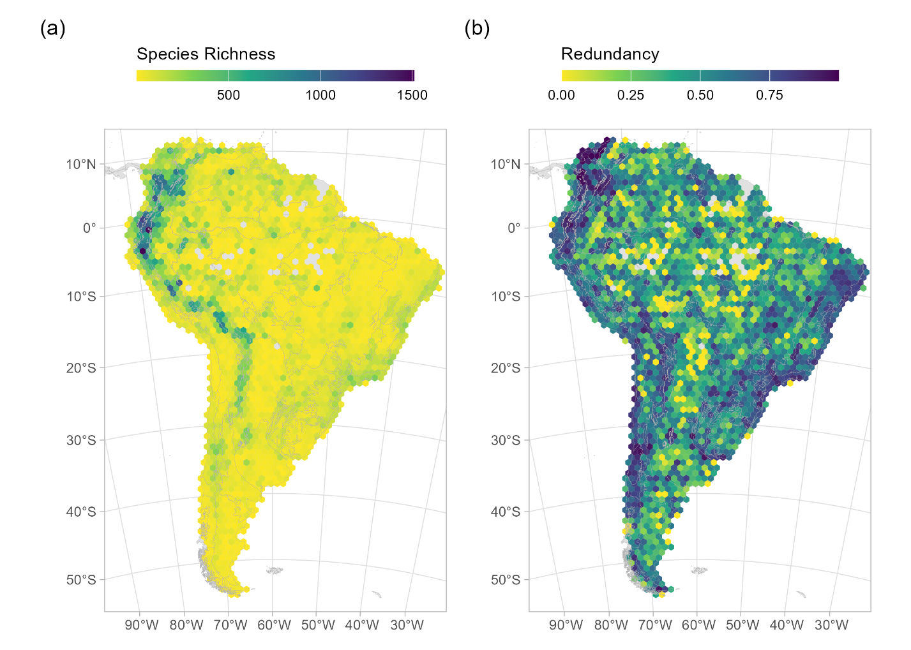

Fig. S2. Spatial pattern of variation in a) phylogenetic diversity (PD and b) PD-significance. PD was computed as the total branch length of the phylogeny connecting all species in each hexagonal cell of 100km in width, indicating the total amount of evolutionary history in each cell. The significance of PD was assessed by a two-tailed randomisation test based on the curveball null model (see main text for detailed explanation and references). PD-significance indicates less evolutionary history than expected by chance, possibly due to phylogenetic clustering (red hues: p <0.025; p <0.01) or higher evolutionary history than expected by change, possibly due to phylogenetic overdispersion (blue hues: p > 0.975; p > 0.99) after controlling for differences in species richness.

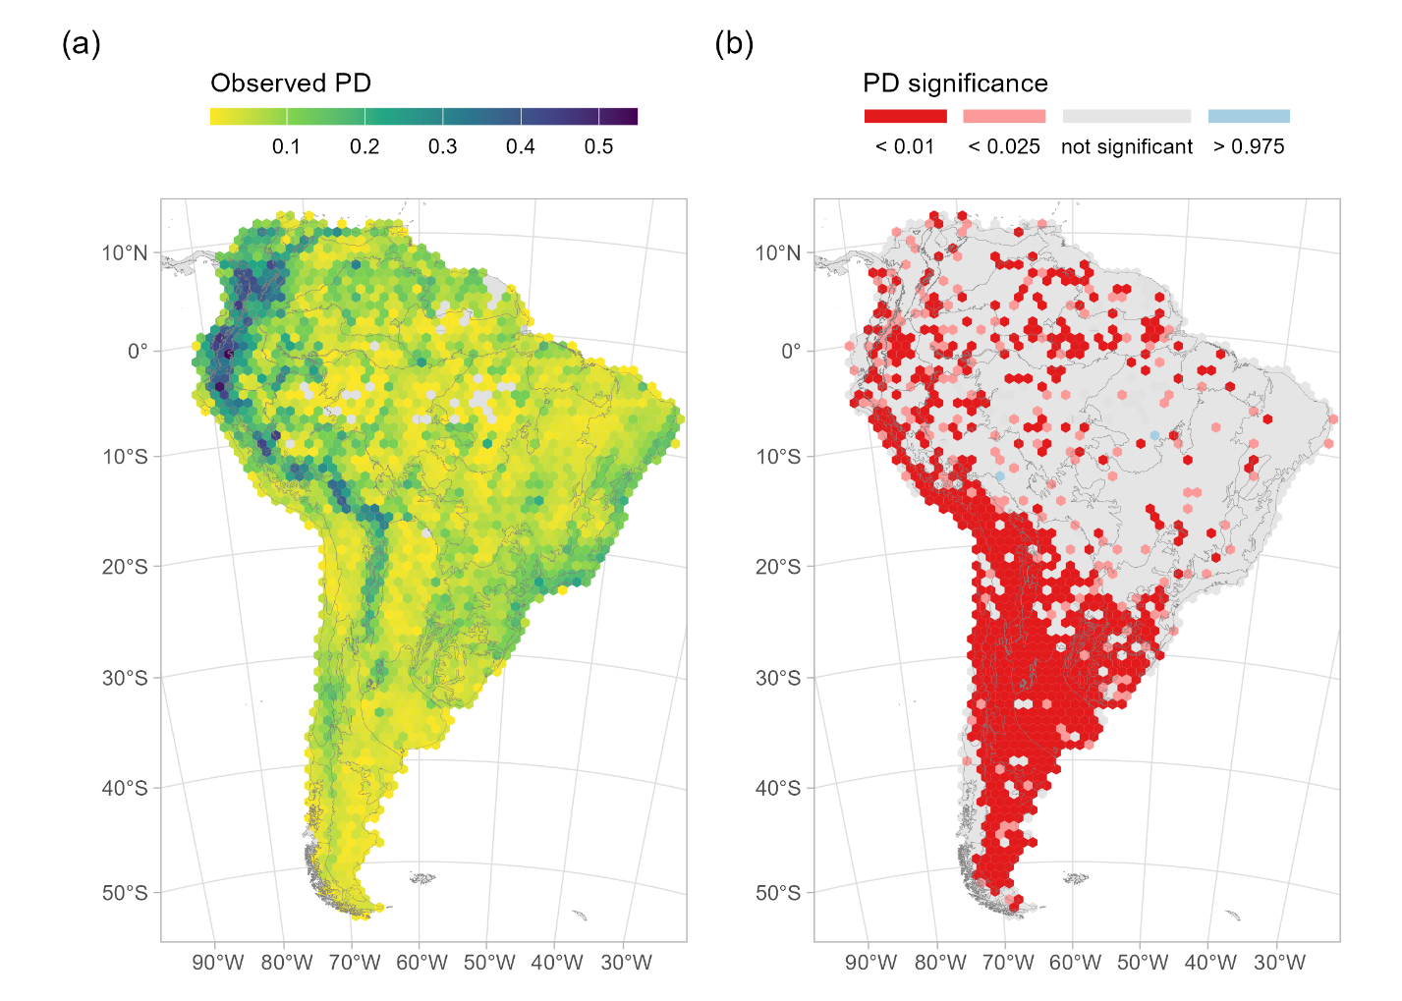

Fig S3. Spatial pattern of variation of a) Relative Phylogenetic Diversity (RPD) and b) RPD-significance. RPD is defined as the ratio of observed PD to the PD expected from a comparative tree with equal branch lengths and the same topology. The significance of RPD was assessed by a two-tailed randomisation test based on the curveball null model (see main text for detailed explanation). RPD significance identifies whether the age structure of a community deviates from random expectation: red hues (p <0.025; p <0.01) indicate higher **phylogenetic clustering of younger lineages** (short branches) than expected by chance; blue hues (p > 0.975; p > 0.99) indicate high **phylogenetic over-representation of ancient lineages** (long branches) compared to random expectation.

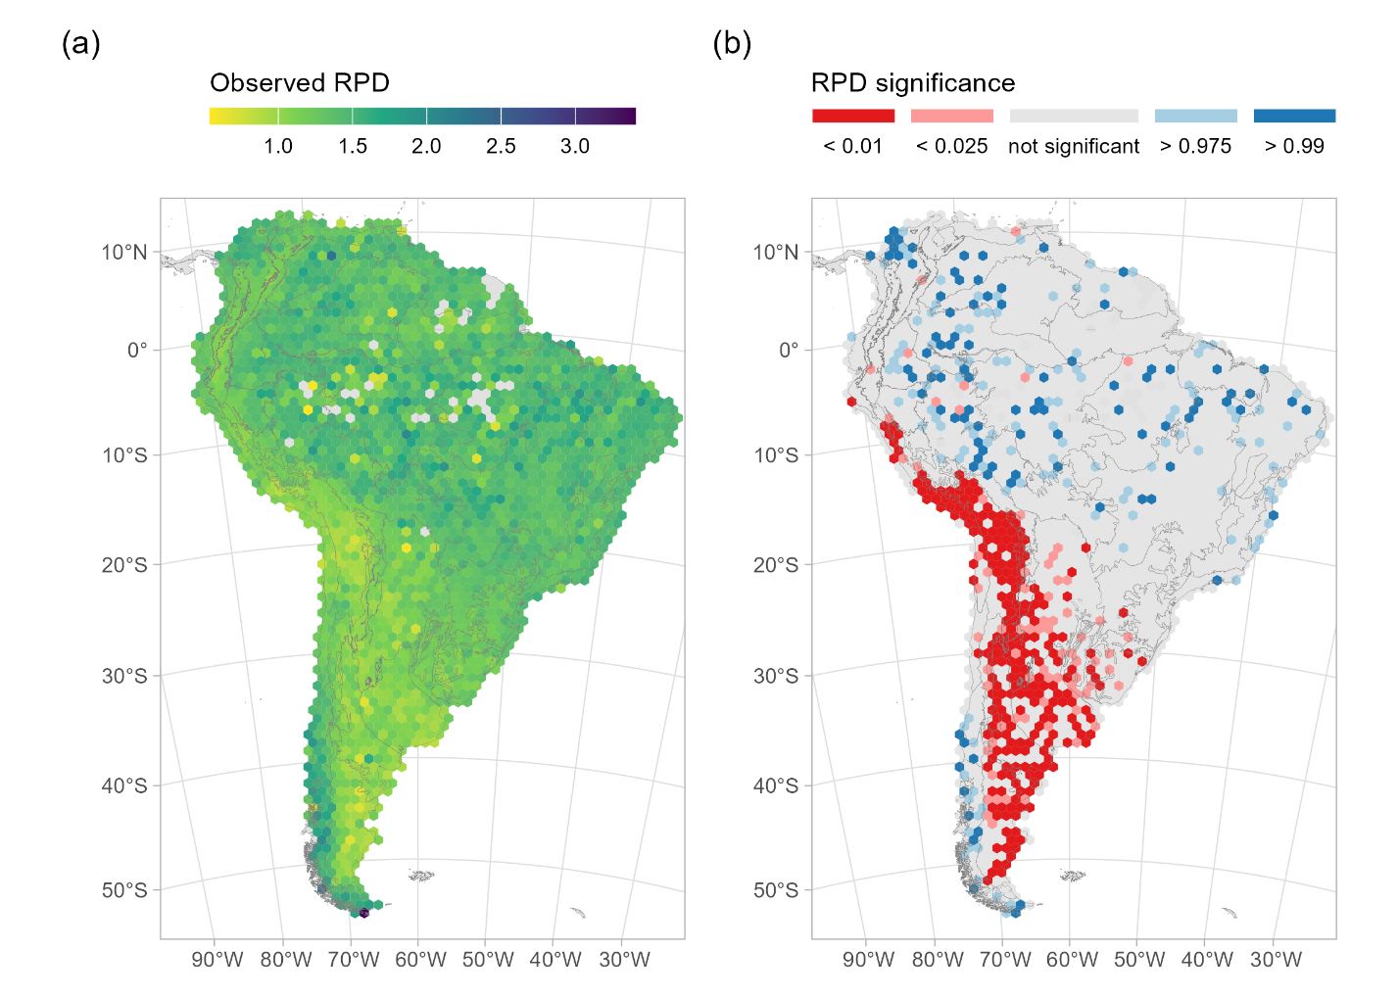

Fig. S4. Spatial patterns of (a) Phylogenetic Endemism (PE) across South America. PE quantifies the degree to which lineages in a community are both phylogenetically distinct and geographically restricted, summing the range-weighted branch lengths of the phylogeny. High PE values (green to blue) indicate concentrations of phylogenetically distinct and/or geographically restricted lineages, while lower values (yellow) indicate predominance of widespread and/or closely related lineages. The significance of PE (b), assessed by a two-tailed randomization test based on the curveball null model (see main text for detailed explanation), indicates higher concentration of widespread and/or closely related lineages (red hues: p < 0.01; p < 0.025) or range restricted and/or evolutionary distinct lineages (blue hues: p > 0.975; p > 0.99) than expected by chance. Grey cells are not statistically significant.

Fig. S5. Spatial patterns of (a) Relative Phylogenetic Endemism (RPE) across South America. **RPE** compares **observed PE** (Phylogenetic Endemism) to the PE expected under a **tree with equal branch lengths** but the same topology to disentangle the evolutionary age of geographically restricted lineages. The (b) significance of RPE, assessed by a two-tailed randomisation test based on the curveball null model (see main text for detailed explanation), indicates high concentration of geographically restricted lineages with evolutionary longer branches (blue hues: p > 0.975; p > 0.99), or high concentration of geographically restricted lineages with evolutionarily shorter branches than expected by chance (red hues: p < 0.025; p<0.01).

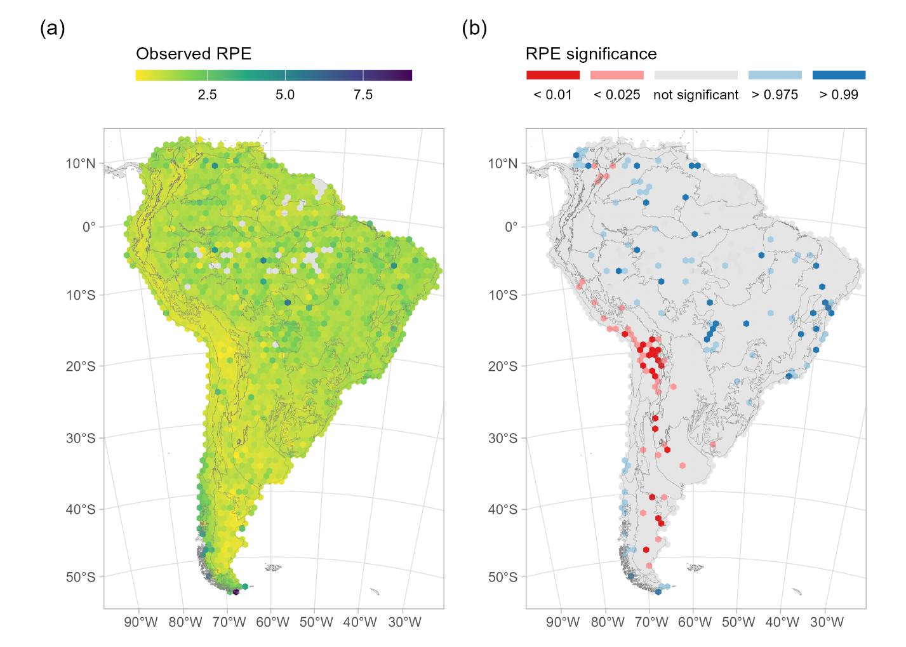

# S03: Statistical Analysis

To test differences in the median of phylogenetic age and each of the environmental variables among CANAPE categories, we applied the non-parametric Kruskal-Wallis’s and Dunn's tests (Z) with Benjamini-Hochberg correction of p-values for multiple comparisons (p.adj). However, given that there is strong spatial autocorrelation in our environmental data (Moran’s I > 0.70, see below), we also used the *effsize* R package (Torchiano & Torchiano, 2020) to calculate the Cliff’s Delta (Cliff, 1993), a non-parametric effect size measure that quantifies the degree of stochastic dominance between two groups that is more robust to lack of independence. Cliff’s Delta values range from –1 to 1, where values near 0 indicate little to no difference. For interpretation, the *effsize* package uses the following thresholds: |δ| < 0.147 indicates a negligible effect, 0.147 ≤ |δ| < 0.33 a small effect, 0.33 ≤ |δ| < 0.474 a medium effect, and |δ| ≥ 0.474 a large effect.

Table S1. Summary of pairwise comparisons of phylogenetic age (mean species age, mean crown family age), present (mean annual temperature and precipitation, temperature and precipitation seasonality) and past () climatic conditions and geological diversityacross CANAPE endemism categories. For each pair of categories, we report the test statistic (Z), unadjusted and Benjamini-Hochberg-adjusted p-values from Dunn’s post-hoc test following a Kruskal-Wallis analysis. Median values and differences between groups for each variable are provided to indicate effect direction and magnitude. Cliff’s Delta estimates are shown alongside their qualitative interpretation (negligible, medium, or large), indicating the strength of group differences based on ordinal dominance.

## Mean species age (m.y.a)

|  |  |  |  |  |  |  |  |  |  |
| --- | --- | --- | --- | --- | --- | --- | --- | --- | --- |
| Group1 | Group2 | Z | p_unadj | p_adj | Median1 | Median2 | Median_Diff | Cliff_Delta | Magnitude |
| mixed | neo | 4.554 | 0.0 | 0.0 | 7.607 | 4.61 | 2.997 | 0.62 | large |
| mixed | not significant | -10.65 | 0.0 | 0.0 | 7.607 | 10.804 | -3.197 | -0.441 | medium |
| neo | not significant | -9.931 | 0.0 | 0.0 | 4.61 | 10.804 | -6.194 | -0.834 | large |
| mixed | paleo | -8.59 | 0.0 | 0.0 | 7.607 | 20.282 | -12.675 | -0.928 | large |
| neo | paleo | -10.193 | 0.0 | 0.0 | 4.61 | 20.282 | -15.673 | -1.0 | large |
| not significant | paleo | -5.845 | 0.0 | 0.0 | 10.804 | 20.282 | -9.478 | -0.924 | large |
| mixed | super | 0.903 | 0.366 | 0.366 | 7.607 | 7.222 | 0.385 | -0.013 | negligible |
| neo | super | -3.208 | 0.001 | 0.001 | 4.61 | 7.222 | -2.612 | -0.745 | large |
| not significant | super | 7.077 | 0.0 | 0.0 | 10.804 | 7.222 | 3.582 | 0.532 | large |
| paleo | super | 8.44 | 0.0 | 0.0 | 20.282 | 7.222 | 13.061 | 0.998 | large |

Kruskal-Wallis Chi-Squared = 280.57, df=4, p-value < 2.2e-16; Moran´s I = 0.27

## Mean Crown Family Age (m.y.a)

|  |  |  |  |  |  |  |  |  |  |
| --- | --- | --- | --- | --- | --- | --- | --- | --- | --- |
| Group1 | Group2 | Z | p_unadj | p_adj | Median1 | Median2 | Median_Diff | Cliff_Delta | Magnitude |
| mixed | neo | 4.313 | 0.000 | 0.000 | 7.203 | 5.277 | 1.926 | 0.522 | large |
| mixed | not significant | -10.084 | 0.000 | 0.000 | 7.203 | 9.251 | -2.048 | -0.416 | medium |
| neo | not significant | -9.403 | 0.000 | 0.000 | 5.277 | 9.251 | -3.974 | -0.800 | large |
| mixed | paleo | -7.858 | 0.000 | 0.000 | 7.203 | 14.534 | -7.332 | -0.885 | large |
| neo | paleo | -9.406 | 0.000 | 0.000 | 5.277 | 14.534 | -9.258 | -0.992 | large |
| not significant | paleo | -5.251 | 0.000 | 0.000 | 9.251 | 14.534 | -5.284 | -0.824 | large |
| mixed | super | 1.332 | 0.183 | 0.183 | 7.203 | 6.894 | 0.308 | 0.049 | negligible |
| neo | super | -2.693 | 0.007 | 0.008 | 5.277 | 6.894 | -1.618 | -0.579 | large |
| not significant | super | 7.234 | 0.000 | 0.000 | 9.251 | 6.894 | 2.357 | 0.537 | large |
| paleo | super | 7.974 | 0.000 | 0.000 | 14.534 | 6.894 | 7.640 | 0.974 | large |

Kruskal-Wallis Chi-Squared = 254.78, df = 4, p-value < 2.2e-16; Moran´s I = 0.27

## Present Climate

### Mean Annual Temperature (BIO1, present)

|  |  |  |  |  |  |  |  |  |  |
| --- | --- | --- | --- | --- | --- | --- | --- | --- | --- |
| Group1 | Group2 | Z | p_unadj | p_adj | Median1 | Median2 | Median_Diff | Cliff_Delta | Magnitude |
| mixed | neo | 1.118 | 0.264 | 0.329 | 106.486 | 79.785 | 26.701 | 0.144 | negligible |
| mixed | not significant | -20.330 | 0.000 | 0.000 | 106.486 | 246.273 | -139.786 | -0.832 | large |
| neo | not significant | -10.758 | 0.000 | 0.000 | 79.785 | 246.273 | -166.487 | -0.928 | large |
| mixed | paleo | -1.121 | 0.262 | 0.375 | 106.486 | 106.555 | -0.068 | -0.073 | negligible |
| neo | paleo | -1.624 | 0.104 | 0.209 | 79.785 | 106.555 | -26.770 | -0.033 | negligible |
| not significant | paleo | 4.584 | 0.000 | 0.000 | 246.273 | 106.555 | 139.718 | 0.616 | large |
| mixed | super | 0.630 | 0.528 | 0.587 | 106.486 | 118.762 | -12.275 | -0.046 | negligible |
| neo | super | -0.492 | 0.623 | 0.623 | 79.785 | 118.762 | -38.977 | -0.232 | small |
| not significant | super | 12.286 | 0.000 | 0.000 | 246.273 | 118.762 | 127.511 | 0.903 | large |
| paleo | super | 1.358 | 0.175 | 0.291 | 106.555 | 118.762 | -12.207 | -0.127 | negligible |

Kruskal-Wallis Chi-Squared = 636.69, df = 4, p-value < 2.2e-16; Moran´s I = 0.71

### Mean Annual Precipitation (BIO12, present)

|  |  |  |  |  |  |  |  |  |  |
| --- | --- | --- | --- | --- | --- | --- | --- | --- | --- |
| Group1 | Group2 | Z | p_unadj | p_adj | Median1 | Median2 | Median_Diff | Cliff_Delta | Magnitude |
| mixed | neo | 1.524 | 0.128 | 0.142 | 549.499 | 295.823 | 253.676 | 0.218 | small |
| mixed | not significant | -15.629 | 0.0 | 0.0 | 549.499 | 1642.85 | -1093.351 | -0.645 | large |
| neo | not significant | -8.989 | 0.0 | 0.0 | 295.823 | 1642.85 | -1347.027 | -0.775 | large |
| mixed | paleo | -2.498 | 0.012 | 0.018 | 549.499 | 1256.218 | -706.719 | -0.484 | large |
| neo | paleo | -3.076 | 0.002 | 0.004 | 295.823 | 1256.218 | -960.395 | -0.719 | large |
| not significant | paleo | 1.838 | 0.066 | 0.083 | 1642.85 | 1256.218 | 386.632 | 0.291 | small |
| mixed | super | 2.863 | 0.004 | 0.007 | 549.499 | 223.627 | 325.872 | 0.337 | medium |
| neo | super | 0.777 | 0.437 | 0.437 | 295.823 | 223.627 | 72.196 | 0.15 | small |
| not significant | super | 12.106 | 0.0 | 0.0 | 1642.85 | 223.627 | 1419.223 | 0.854 | large |
| paleo | super | 3.756 | 0.0 | 0.0 | 1256.218 | 223.627 | 1032.591 | 0.739 | large |

Kruskal-Wallis Chi-Squared = 431.63, df = 4, p-value < 2.2e-16; Moran´s I = 0.85

### Temperature Seasonality (BIO4, present)

|  |  |  |  |  |  |  |  |  |  |
| --- | --- | --- | --- | --- | --- | --- | --- | --- | --- |
| Group1 | Group2 | Z | p_unadj | p_adj | Median1 | Median2 | Median_Diff | Cliff_Delta | Magnitude |
| mixed | neo | -0.059 | 0.953 | 0.953 | 2734.198 | 2583.021 | 151.178 | 0.045 | negligible |
| mixed | not significant | 8.062 | 0.000 | 0.000 | 2734.198 | 1024.843 | 1709.355 | 0.329 | small |
| neo | not significant | 3.850 | 0.000 | 0.000 | 2583.021 | 1024.843 | 1558.178 | 0.345 | medium |
| mixed | paleo | -1.167 | 0.243 | 0.348 | 2734.198 | 2614.607 | 119.592 | -0.033 | negligible |
| neo | paleo | -1.004 | 0.315 | 0.394 | 2583.021 | 2614.607 | -31.586 | -0.108 | negligible |
| not significant | paleo | -3.478 | 0.001 | 0.001 | 1024.843 | 2614.607 | -1589.764 | -0.534 | large |
| mixed | super | -1.731 | 0.084 | 0.167 | 2734.198 | 3555.305 | -821.107 | -0.177 | small |
| neo | super | -1.200 | 0.230 | 0.383 | 2583.021 | 3555.305 | -972.284 | -0.225 | small |
| not significant | super | -6.529 | 0.000 | 0.000 | 1024.843 | 3555.305 | -2530.462 | -0.460 | medium |
| paleo | super | 0.219 | 0.827 | 0.918 | 2614.607 | 3555.305 | -940.698 | -0.233 | small |

Kruskal-Wallis Chi-Squared = 121.6, df = 4, p-value < 2.2e-16; Moran´s I = 0.97

### Precipitation seasonality (BIO15, present)

|  |  |  |  |  |  |  |  |  |  |
| --- | --- | --- | --- | --- | --- | --- | --- | --- | --- |
| Group1 | Group2 | Z | p_unadj | p_adj | Median1 | Median2 | Median_Diff | Cliff_Delta | Magnitude |
| mixed | neo | -4.388 | 0.000 | 0.000 | 65.344 | 110.102 | -44.758 | -0.415 | medium |
| mixed | not significant | 4.975 | 0.000 | 0.000 | 65.344 | 55.924 | 9.420 | 0.200 | small |
| neo | not significant | 7.085 | 0.000 | 0.000 | 110.102 | 55.924 | 54.178 | 0.610 | large |
| mixed | paleo | 1.993 | 0.046 | 0.058 | 65.344 | 42.901 | 22.443 | 0.299 | small |
| neo | paleo | 4.235 | 0.000 | 0.000 | 110.102 | 42.901 | 67.201 | 0.686 | large |
| not significant | paleo | 0.650 | 0.516 | 0.516 | 55.924 | 42.901 | 13.023 | 0.100 | negligible |
| mixed | super | -6.436 | 0.000 | 0.000 | 65.344 | 97.808 | -32.464 | -0.418 | medium |
| neo | super | -0.930 | 0.352 | 0.391 | 110.102 | 97.808 | 12.294 | 0.103 | negligible |
| not significant | super | -10.035 | 0.000 | 0.000 | 55.924 | 97.808 | -41.884 | -0.740 | large |
| paleo | super | -5.074 | 0.000 | 0.000 | 42.901 | 97.808 | -54.907 | -0.681 | large |

Kruskal-Wallis Chi-Squared = 163.95, df = 4, p-value < 2.2e-16; Moran´s I = 0.85

## Late Holocene Climate

### Mean Annual Temperature (BIO1, Late Holocene)

|  |  |  |  |  |  |  |  |  |  |
| --- | --- | --- | --- | --- | --- | --- | --- | --- | --- |
| Group1 | Group2 | Z | p_unadj | p_adj | Median1 | Median2 | Median_Diff | Cliff_Delta | Magnitude |
| mixed | neo | 1.155 | 0.248 | 0.354 | 98.501 | 72.998 | 25.503 | 0.148 | small |
| mixed | not significant | -20.398 | 0.0 | 0.0 | 98.501 | 238.187 | -139.687 | -0.834 | large |
| neo | not significant | -10.83 | 0.0 | 0.0 | 72.998 | 238.187 | -165.19 | -0.934 | large |
| mixed | paleo | -1.086 | 0.277 | 0.347 | 98.501 | 100.104 | -1.603 | 0.069 | negligible |
| neo | paleo | -1.614 | 0.106 | 0.213 | 72.998 | 100.104 | -27.106 | -0.044 | negligible |
| not significant | paleo | 4.639 | 0.0 | 0.0 | 238.187 | 100.104 | 138.084 | 0.625 | large |
| mixed | super | 0.628 | 0.53 | 0.589 | 98.501 | 111.503 | -13.003 | -0.055 | negligible |
| neo | super | -0.525 | 0.599 | 0.599 | 72.998 | 111.503 | -38.506 | -0.25 | small |
| not significant | super | 12.322 | 0.0 | 0.0 | 238.187 | 111.503 | 126.684 | 0.907 | large |
| paleo | super | 1.325 | 0.185 | 0.309 | 100.104 | 111.503 | -11.4 | 0.125 | negligible |

Kruskal-Wallis Chi-squared = 641.83, df = 4, p-value < 2.2e-16; Moran´s I = 0.70

### Mean Annual Precipitation (BIO12, Late Holocene)

|  |  |  |  |  |  |  |  |  |  |
| --- | --- | --- | --- | --- | --- | --- | --- | --- | --- |
| Group1 | Group2 | Z | p_unadj | p_adj | Median1 | Median2 | Median_Diff | Cliff_Delta | Magnitude |
| mixed | neo | 1.505 | 0.132 | 0.147 | 530.180 | 286.947 | 243.232 | 0.212 | small |
| mixed | not significant | -15.616 | 0.000 | 0.000 | 530.180 | 1626.776 | -1096.596 | -0.644 | large |
| neo | not significant | -8.963 | 0.000 | 0.000 | 286.947 | 1626.776 | -1339.829 | -0.773 | large |
| mixed | paleo | -2.627 | 0.009 | 0.012 | 530.180 | 1275.284 | -745.105 | -0.497 | large |
| neo | paleo | -3.180 | 0.001 | 0.003 | 286.947 | 1275.284 | -988.337 | -0.725 | large |
| not significant | paleo | 1.701 | 0.089 | 0.111 | 1626.776 | 1275.284 | 351.492 | 0.269 | small |
| mixed | super | 2.917 | 0.004 | 0.006 | 530.180 | 229.341 | 300.838 | 0.337 | medium |
| neo | super | -0.832 | 0.405 | 0.405 | 286.947 | 229.341 | 57.606 | -0.150 | small |
| not significant | super | 12.159 | 0.000 | 0.000 | 1626.776 | 229.341 | 1397.435 | 0.858 | large |
| paleo | super | 3.903 | 0.000 | 0.000 | 1275.284 | 229.341 | 1045.943 | 0.741 | large |

Kruskal-Wallis chi-squared = 431.75, df = 4, p-value < 2.2e-16; Moran´s I = 0.85

### Temperature Seasonality (BIO4, Late Holocene)

|  |  |  |  |  |  |  |  |  |  |
| --- | --- | --- | --- | --- | --- | --- | --- | --- | --- |
| Group1 | Group2 | Z | p_unadj | p_adj | Median1 | Median2 | Median_Diff | Cliff_Delta | Magnitude |
| mixed | neo | 0.431 | 0.667 | 0.741 | 2917.823 | 2914.993 | 2.830 | 0.012 | negligible |
| mixed | not significant | 6.514 | 0.000 | 0.000 | 2917.823 | 1396.738 | 1521.085 | 0.264 | small |
| neo | not significant | 3.525 | 0.000 | 0.001 | 2914.993 | 1396.738 | 1518.255 | 0.315 | small |
| mixed | paleo | 1.467 | 0.142 | 0.237 | 2917.823 | 2768.773 | 149.051 | 0.019 | negligible |
| neo | paleo | 1.063 | 0.288 | 0.411 | 2914.993 | 2768.773 | 146.220 | 0.050 | negligible |
| not significant | paleo | -3.351 | 0.001 | 0.002 | 1396.738 | 2768.773 | -1372.034 | -0.526 | large |
| mixed | super | -1.929 | 0.054 | 0.107 | 2917.823 | 3673.165 | -755.342 | -0.171 | small |
| neo | super | -1.029 | 0.304 | 0.380 | 2914.993 | 3673.165 | -758.172 | -0.186 | small |
| not significant | super | -5.869 | 0.000 | 0.000 | 1396.738 | 3673.165 | -2276.427 | -0.415 | medium |
| paleo | super | -0.399 | 0.690 | 0.690 | 2768.773 | 3673.165 | -904.393 | -0.239 | small |

Kruskal-Wallis chi-squared = 90.717, df = 4, p-value < 2.2e-16; Moran´s I = 0.97

### Precipitation Seasonality (BIO15, Late Holocene)

|  |  |  |  |  |  |  |  |  |  |
| --- | --- | --- | --- | --- | --- | --- | --- | --- | --- |
| Group1 | Group2 | Z | p_unadj | p_adj | Median1 | Median2 | Median_Diff | Cliff_Delta | Magnitude |
| mixed | neo | -4.322 | 0.000 | 0.000 | 67.927 | 118.493 | -50.566 | -0.418 | medium |
| mixed | not significant | 5.874 | 0.000 | 0.000 | 67.927 | 57.322 | 10.605 | 0.234 | small |
| neo | not significant | 7.437 | 0.000 | 0.000 | 118.493 | 57.322 | 61.171 | 0.634 | large |
| mixed | paleo | 2.285 | 0.022 | 0.028 | 67.927 | 43.264 | 24.663 | 0.360 | medium |
| neo | paleo | 4.457 | 0.000 | 0.000 | 118.493 | 43.264 | 75.229 | 0.706 | large |
| not significant | paleo | 0.697 | 0.486 | 0.486 | 57.322 | 43.264 | 14.058 | 0.105 | negligible |
| mixed | super | -6.299 | 0.000 | 0.000 | 67.927 | 102.822 | -34.895 | -0.329 | small |
| neo | super | -0.888 | 0.375 | 0.416 | 118.493 | 102.822 | 15.671 | 0.262 | small |
| not significant | super | -10.395 | 0.000 | 0.000 | 57.322 | 102.822 | -45.500 | -0.780 | large |
| paleo | super | -5.278 | 0.000 | 0.000 | 43.264 | 102.822 | -59.558 | -0.720 | large |

Kruskal-Wallis chi-squared = 183.88, df = 4, p-value < 2.2e-16; Moran´s I = 0.88)

## Last Glacial Maximum Climate

### Mean Annual Temperature (BIO1, Last Glacial Maximum)

|  |  |  |  |  |  |  |  |  |  |
| --- | --- | --- | --- | --- | --- | --- | --- | --- | --- |
| Group1 | Group2 | Z | p_unadj | p_adj | Median1 | Median2 | Median_Diff | Cliff_Delta | Magnitude |
| mixed | neo | 1.661 | 0.097 | 0.161 | 82.275 | 61.933 | 20.343 | 0.125 | negligible |
| mixed | not significant | -17.565 | 0.0 | 0.0 | 82.275 | 212.832 | -130.556 | -0.742 | large |
| neo | not significant | -10.394 | 0.0 | 0.0 | 61.933 | 212.832 | -150.899 | -0.904 | large |
| mixed | paleo | -1.624 | 0.104 | 0.149 | 82.275 | 123.478 | -41.202 | -0.277 | small |
| neo | paleo | -2.287 | 0.022 | 0.044 | 61.933 | 123.478 | -61.545 | -0.444 | medium |
| not significant | paleo | 2.426 | 0.015 | 0.038 | 212.832 | 123.478 | 89.354 | 0.437 | medium |
| mixed | super | -0.014 | 0.989 | 0.989 | 82.275 | 98.075 | -15.8 | -0.134 | negligible |
| neo | super | -1.429 | 0.153 | 0.17 | 61.933 | 98.075 | -36.142 | -0.311 | small |
| not significant | super | 10.394 | 0.0 | 0.0 | 212.832 | 98.075 | 114.757 | 0.767 | large |
| paleo | super | 1.546 | 0.122 | 0.153 | 123.478 | 98.075 | 25.403 | 0.194 | small |

Kruskal-Wallis chi-squared = 484.91, df = 4, p-value < 2.2e-16; Moran´s I = 0.88

### Mean Annual Precipitation (BIO12, Last Glacial Maximum)

|  |  |  |  |  |  |  |  |  |  |
| --- | --- | --- | --- | --- | --- | --- | --- | --- | --- |
| Group1 | Group2 | Z | p_unadj | p_adj | Median1 | Median2 | Median_Diff | Cliff_Delta | Magnitude |
| mixed | neo | 1.661 | 0.097 | 0.161 | 82.275 | 61.933 | 20.343 | 0.185 | small |
| mixed | not significant | -17.565 | 0.000 | 0.000 | 82.275 | 212.832 | -130.556 | -0.644 | large |
| neo | not significant | -10.394 | 0.000 | 0.000 | 61.933 | 212.832 | -150.899 | -0.787 | large |
| mixed | paleo | -1.624 | 0.104 | 0.149 | 82.275 | 123.478 | -41.202 | -0.470 | medium |
| neo | paleo | -2.287 | 0.022 | 0.044 | 61.933 | 123.478 | -61.545 | -0.664 | large |
| not significant | paleo | 2.426 | 0.015 | 0.038 | 212.832 | 123.478 | 89.354 | 0.236 | small |
| mixed | super | -0.014 | 0.989 | 0.989 | 82.275 | 98.075 | -15.800 | -0.285 | small |
| neo | super | -1.429 | 0.153 | 0.170 | 61.933 | 98.075 | -36.142 | -0.122 | negligible |
| not significant | super | 10.394 | 0.000 | 0.000 | 212.832 | 98.075 | 114.757 | 0.838 | large |
| paleo | super | 1.546 | 0.122 | 0.153 | 123.478 | 98.075 | 25.403 | 0.666 | large |

Kruskal-Wallis chi-squared = 426.42, df = 4, p-value < 2.2e-16; Moran´s I = 0.88

### Temperature Seasonality (BIO4, Last Glacial Maximum)

|  |  |  |  |  |  |  |  |  |  |
| --- | --- | --- | --- | --- | --- | --- | --- | --- | --- |
| Group1 | Group2 | Z | p_unadj | p_adj | Median1 | Median2 | Median_Diff | Cliff_Delta | Magnitude |
| mixed | neo | -0.218 | 0.097 | 0.161 | 2368.051 | 2146.153 | 221.898 | 0.038 | negligible |
| mixed | not significant | 6.814 | 0.000 | 0.000 | 2368.051 | 1269.146 | 1098.905 | 0.279 | small |
| neo | not significant | 3.436 | 0.001 | 0.002 | 2146.153 | 1269.146 | 877.008 | 0.311 | small |
| mixed | paleo | -1.419 | 0.156 | 0.260 | 2368.051 | 3504.364 | -1136.313 | -0.164 | small |
| neo | paleo | -1.139 | 0.255 | 0.318 | 2146.153 | 3504.364 | -1358.210 | -0.344 | medium |
| not significant | paleo | -3.386 | 0.001 | 0.002 | 1269.146 | 3504.364 | -2235.218 | -0.501 | large |
| mixed | super | -1.938 | 0.053 | 0.105 | 2368.051 | 3890.053 | -1522.002 | -0.201 | small |
| neo | super | -1.215 | 0.224 | 0.320 | 2146.153 | 3890.053 | -1743.899 | -0.208 | small |
| not significant | super | -6.050 | 0.000 | 0.000 | 1269.146 | 3890.053 | -2620.907 | -0.425 | medium |
| paleo | super | 0.350 | 0.726 | 0.807 | 3504.364 | 3890.053 | -385.689 | 0.149 | small |

Kruskal-Wallis chi-squared = 96.004, df = 4, p-value < 2.2e-16; Moran´s I = 0.97

### Precipitation Seasonality (BIO15, Last Glacial Maximum)

|  |  |  |  |  |  |  |  |  |  |
| --- | --- | --- | --- | --- | --- | --- | --- | --- | --- |
| Group1 | Group2 | Z | p_unadj | p_adj | Median1 | Median2 | Median_Diff | Cliff_Delta | Magnitude |
| mixed | neo | -4.907 | 0.000 | 0.000 | 61.668 | 107.089 | -45.421 | -0.426 | medium |
| mixed | not significant | 3.755 | 0.000 | 0.000 | 61.668 | 54.157 | 7.510 | 0.149 | small |
| neo | not significant | 7.074 | 0.000 | 0.000 | 107.089 | 54.157 | 52.931 | 0.616 | large |
| mixed | paleo | 1.687 | 0.092 | 0.114 | 61.668 | 40.804 | 20.863 | 0.247 | small |
| neo | paleo | 4.254 | 0.000 | 0.000 | 107.089 | 40.804 | 66.284 | 0.653 | large |
| not significant | paleo | 0.679 | 0.497 | 0.553 | 54.157 | 40.804 | 13.353 | 0.106 | negligible |
| mixed | super | -6.319 | 0.000 | 0.000 | 61.668 | 93.616 | -31.948 | -0.419 | medium |
| neo | super | -0.406 | 0.685 | 0.685 | 107.089 | 93.616 | 13.473 | 0.107 | negligible |
| not significant | super | -9.209 | 0.000 | 0.000 | 54.157 | 93.616 | -39.458 | -0.678 | large |
| paleo | super | -4.731 | 0.000 | 0.000 | 40.804 | 93.616 | -52.811 | 0.623 | large |

Kruskal-Wallis chi-squared = 140.18, df = 4, p-value < 2.2e-16; Moran´s I = 0.87

## Last Interglacial Climate

### Mean Annual Temperature (BIO1, Last Interglacial)

|  |  |  |  |  |  |  |  |  |  |
| --- | --- | --- | --- | --- | --- | --- | --- | --- | --- |
| Group1 | Group2 | Z | p_unadj | p_adj | Median1 | Median2 | Median_Diff | Cliff_Delta | Magnitude |
| mixed | neo | 1.259 | 0.208 | 0.297 | 95.588 | 70.286 | 25.302 | 0.174 | small |
| mixed | not significant | -20.171 | 0.0 | 0.0 | 95.588 | 235.568 | -139.98 | -0.825 | large |
| neo | not significant | -10.836 | 0.0 | 0.0 | 70.286 | 235.568 | -165.282 | -0.931 | large |
| mixed | paleo | -1.09 | 0.275 | 0.344 | 95.588 | 97.352 | -1.764 | -0.048 | negligible |
| neo | paleo | -1.676 | 0.094 | 0.187 | 70.286 | 97.352 | -27.066 | -0.106 | negligible |
| not significant | paleo | 4.57 | 0.0 | 0.0 | 235.568 | 97.352 | 138.216 | 0.619 | large |
| mixed | super | 0.649 | 0.516 | 0.573 | 95.588 | 108.392 | -12.804 | -0.056 | negligible |
| neo | super | -0.598 | 0.55 | 0.55 | 70.286 | 108.392 | -38.106 | -0.272 | small |
| not significant | super | 12.217 | 0.0 | 0.0 | 235.568 | 108.392 | 127.175 | 0.9 | large |
| paleo | super | 1.339 | 0.181 | 0.301 | 97.352 | 108.392 | -11.041 | -0.116 | negligible |

Kruskal-Wallis chi-squared = 630.55, df = 4, p-value < 2.2e-16; Moran´s I = 0.71

### Mean Annual Precipitation (BIO4, Last Interglacial)

|  |  |  |  |  |  |  |  |  |  |
| --- | --- | --- | --- | --- | --- | --- | --- | --- | --- |
| Group1 | Group2 | Z | p_unadj | p_adj | Median1 | Median2 | Median_Diff | Cliff_Delta | Magnitude |
| mixed | neo | 1.407 | 0.159 | 0.199 | 530.255 | 332.097 | 198.158 | 0.158 | small |
| mixed | not significant | -15.022 | 0.000 | 0.000 | 530.255 | 1556.802 | -1026.548 | -0.619 | large |
| neo | not significant | -8.578 | 0.000 | 0.000 | 332.097 | 1556.802 | -1224.706 | -0.748 | large |
| mixed | paleo | -2.759 | 0.006 | 0.008 | 530.255 | 1283.805 | -753.550 | -0.481 | large |
| neo | paleo | -3.243 | 0.001 | 0.002 | 332.097 | 1283.805 | -951.709 | -0.683 | large |
| not significant | paleo | 1.397 | 0.162 | 0.180 | 1556.802 | 1283.805 | 272.997 | 0.217 | small |
| mixed | super | 3.037 | 0.002 | 0.004 | 530.255 | 224.946 | 305.309 | 0.361 | medium |
| neo | super | 1.001 | 0.317 | 0.317 | 332.097 | 224.946 | 107.151 | -0.229 | small |
| not significant | super | 11.955 | 0.000 | 0.000 | 1556.802 | 224.946 | 1331.857 | 0.841 | large |
| paleo | super | 4.085 | 0.000 | 0.000 | 1283.805 | 224.946 | 1058.859 | 0.724 | large |

Kruskal-Wallis chi-squared = 404.01, df = 4, p-value < 2.2e-16; Moran´s I = 0.71

### Temperature Seasonality (BIO4, Last Interglacial)

|  |  |  |  |  |  |  |  |  |  |
| --- | --- | --- | --- | --- | --- | --- | --- | --- | --- |
| Group1 | Group2 | Z | p_unadj | p_adj | Median1 | Median2 | Median_Diff | Cliff_Delta | Magnitude |
| mixed | neo | 2.859 | 0.004 | 0.007 | 1821.408 | 1336.963 | 484.445 | 0.18 | small |
| mixed | not significant | 1.462 | 0.144 | 0.16 | 1821.408 | 1656.174 | 165.234 | 0.06 | negligible |
| neo | not significant | -2.408 | 0.016 | 0.02 | 1336.963 | 1656.174 | -319.211 | -0.225 | small |
| mixed | paleo | -2.837 | 0.005 | 0.007 | 1821.408 | 2351.334 | -529.926 | -0.23 | small |
| neo | paleo | -4.127 | 0.0 | 0.0 | 1336.963 | 2351.334 | -1014.37 | -0.658 | large |
| not significant | paleo | -3.336 | 0.001 | 0.002 | 1656.174 | 2351.334 | -695.16 | -0.519 | large |
| mixed | super | -3.199 | 0.001 | 0.003 | 1821.408 | 2935.285 | -1113.877 | -0.238 | small |
| neo | super | -4.734 | 0.0 | 0.0 | 1336.963 | 2935.285 | -1598.322 | -0.419 | medium |
| not significant | super | -4.412 | 0.0 | 0.0 | 1656.174 | 2935.285 | -1279.112 | -0.32 | small |
| paleo | super | 1.038 | 0.299 | 0.299 | 2351.334 | 2935.285 | -583.951 | -0.093 | negligible |

Kruskal-Wallis chi-squared = 38.255, df = 4, p-value = 9.925e-08; Moran´s I = 0.97

### Precipitation Seasonality (BIO15, Last Interglacial)

|  |  |  |  |  |  |  |  |  |  |
| --- | --- | --- | --- | --- | --- | --- | --- | --- | --- |
| Group1 | Group2 | Z | p_unadj | p_adj | Median1 | Median2 | Median_Diff | Cliff_Delta | Magnitude |
| mixed | neo | -4.179 | 0.0 | 0.0 | 70.794 | 102.734 | -31.94 | -0.387 | medium |
| mixed | not significant | 6.467 | 0.0 | 0.0 | 70.794 | 59.214 | 11.58 | 0.263 | small |
| neo | not significant | 7.56 | 0.0 | 0.0 | 102.734 | 59.214 | 43.52 | -0.655 | large |
| mixed | paleo | 2.429 | 0.015 | 0.019 | 70.794 | 45.007 | 25.787 | 0.345 | medium |
| neo | paleo | 4.505 | 0.0 | 0.0 | 102.734 | 45.007 | 57.727 | 0.667 | large |
| not significant | paleo | 0.678 | 0.498 | 0.553 | 59.214 | 45.007 | 14.207 | 0.108 | negligible |
| mixed | super | -4.902 | 0.0 | 0.0 | 70.794 | 93.908 | -23.114 | -0.34 | medium |
| neo | super | 0.0 | 1.0 | 1.0 | 102.734 | 93.908 | 8.826 | -0.137 | negligible |
| not significant | super | -9.169 | 0.0 | 0.0 | 59.214 | 93.908 | -34.694 | -0.67 | large |
| paleo | super | -4.712 | 0.0 | 0.0 | 45.007 | 93.908 | -48.901 | 0.612 | large |

Kruskal-Wallis chi-squared = 169.07, df = 4, p-value < 2.2e-16; Moran´s I = 0.86

## Pliocene Climate

### Mean Annual Temperature (BIO1, Pliocene)

|  |  |  |  |  |  |  |  |  |  |
| --- | --- | --- | --- | --- | --- | --- | --- | --- | --- |
| Group1 | Group2 | Z | p_unadj | p_adj | Median1 | Median2 | Median_Diff | Cliff_Delta | Magnitude |
| mixed | neo | 1.006 | 0.315 | 0.393 | 122.777 | 94.576 | 28.201 | 0.127 | negligible |
| mixed | not significant | -20.443 | 0.000 | 0.000 | 122.777 | 268.100 | -145.323 | -0.837 | large |
| neo | not significant | -10.689 | 0.000 | 0.000 | 94.576 | 268.100 | -173.524 | -0.924 | large |
| mixed | paleo | -1.105 | 0.269 | 0.385 | 122.777 | 119.411 | 3.366 | 0.095 | negligible |
| neo | paleo | -1.547 | 0.122 | 0.244 | 94.576 | 119.411 | -24.835 | -0.053 | negligible |
| not significant | paleo | 4.632 | 0.000 | 0.000 | 268.100 | 119.411 | 148.690 | 0.618 | large |
| mixed | super | 0.670 | 0.503 | 0.559 | 122.777 | 134.212 | -11.435 | -0.030 | negligible |
| neo | super | -0.368 | 0.713 | 0.713 | 94.576 | 134.212 | -39.636 | -0.207 | small |
| not significant | super | 12.394 | 0.000 | 0.000 | 268.100 | 134.212 | 133.889 | 0.908 | large |
| paleo | super | 1.363 | 0.173 | 0.288 | 119.411 | 134.212 | -14.801 | -0.131 | negligible |

Kruskal-Wallis chi-squared = 642.42, df = 4, p-value < 2.2e-16; Moran´s I = 0.72

### Mean Annual Precipitation (BIO12, Pliocene)

|  |  |  |  |  |  |  |  |  |  |
| --- | --- | --- | --- | --- | --- | --- | --- | --- | --- |
| Group1 | Group2 | Z | p_unadj | p_adj | Median1 | Median2 | Median_Diff | Cliff_Delta | Magnitude |
| mixed | neo | 1.729 | 0.084 | 0.093 | 607.756 | 340.643 | 267.113 | 0.183 | small |
| mixed | not significant | -14.548 | 0.000 | 0.000 | 607.756 | 1648.108 | -1040.351 | -0.600 | large |
| neo | not significant | -8.703 | 0.000 | 0.000 | 340.643 | 1648.108 | -1307.464 | -0.760 | large |
| mixed | paleo | -2.125 | 0.034 | 0.048 | 607.756 | 1088.148 | -480.391 | -0.415 | medium |
| neo | paleo | -2.860 | 0.004 | 0.007 | 340.643 | 1088.148 | -747.504 | -0.683 | large |
| not significant | paleo | 1.916 | 0.055 | 0.069 | 1648.108 | 1088.148 | 559.960 | 0.300 | small |
| mixed | super | 3.134 | 0.002 | 0.003 | 607.756 | 207.283 | 400.473 | 0.374 | medium |
| neo | super | 0.799 | 0.424 | 0.424 | 340.643 | 207.283 | 133.360 | 0.238 | small |
| not significant | super | 11.794 | 0.000 | 0.000 | 1648.108 | 207.283 | 1440.824 | 0.827 | large |
| paleo | super | 3.545 | 0.000 | 0.001 | 1088.148 | 207.283 | 880.864 | 0.683 | large |

Kruskal-Wallis chi-squared = 390.45, df = 4, p-value < 2.2e-16; Moran´s I = 0.85

### Temperature Seasonality (BIO4, Pliocene)

|  |  |  |  |  |  |  |  |  |  |
| --- | --- | --- | --- | --- | --- | --- | --- | --- | --- |
| Group1 | Group2 | Z | p_unadj | p_adj | Median1 | Median2 | Median_Diff | Cliff_Delta | Magnitude |
| mixed | neo | -0.482 | 0.630 | 0.700 | 2594.069 | 2701.553 | -107.484 | -0.005 | negligible |
| mixed | not significant | 4.616 | 0.000 | 0.000 | 2594.069 | 1704.833 | 889.236 | 0.187 | small |
| neo | not significant | 2.689 | 0.007 | 0.024 | 2701.553 | 1704.833 | 996.720 | 0.242 | small |
| mixed | paleo | -0.964 | 0.335 | 0.559 | 2594.069 | 2473.809 | 120.261 | 0.022 | negligible |
| neo | paleo | -0.587 | 0.557 | 0.697 | 2701.553 | 2473.809 | 227.745 | 0.033 | negligible |
| not significant | paleo | -2.296 | 0.022 | 0.054 | 1704.833 | 2473.809 | -768.975 | -0.358 | medium |
| mixed | super | -1.883 | 0.060 | 0.119 | 2594.069 | 3861.879 | -1267.810 | -0.168 | small |
| neo | super | -0.952 | 0.341 | 0.487 | 2701.553 | 3861.879 | -1160.326 | -0.181 | small |
| not significant | super | -4.737 | 0.000 | 0.000 | 1704.833 | 3861.879 | -2157.046 | -0.335 | medium |
| paleo | super | -0.046 | 0.963 | 0.963 | 2473.809 | 3861.879 | -1388.071 | -0.213 | small |

Kruskal-Wallis chi-squared = 50.788, df = 4, p-value = 2.472e-10; Moran´s I = 0.97

### Precipitation Seasonality (BIO15, Pliocene)

|  |  |  |  |  |  |  |  |  |  |
| --- | --- | --- | --- | --- | --- | --- | --- | --- | --- |
| Group1 | Group2 | Z | p_unadj | p_adj | Median1 | Median2 | Median_Diff | Cliff_Delta | Magnitude |
| mixed | neo | -3.762 | 0.000 | 0.000 | 70.967 | 93.506 | -22.539 | -0.329 | small |
| mixed | not significant | 3.681 | 0.000 | 0.000 | 70.967 | 63.769 | 7.198 | 0.151 | small |
| neo | not significant | 5.800 | 0.000 | 0.000 | 93.506 | 63.769 | 29.736 | 0.515 | large |
| mixed | paleo | 1.630 | 0.103 | 0.129 | 70.967 | 53.013 | 17.954 | 0.211 | small |
| neo | paleo | 3.561 | 0.000 | 0.001 | 93.506 | 53.013 | 40.492 | 0.447 | medium |
| not significant | paleo | 0.641 | 0.521 | 0.521 | 63.769 | 53.013 | 10.756 | 0.106 | negligible |
| mixed | super | -6.376 | 0.000 | 0.000 | 70.967 | 113.420 | -42.453 | -0.519 | large |
| neo | super | -1.418 | 0.156 | 0.174 | 93.506 | 113.420 | -19.915 | -0.278 | small |
| not significant | super | -9.231 | 0.000 | 0.000 | 63.769 | 113.420 | -49.651 | -0.661 | large |
| paleo | super | -4.707 | 0.000 | 0.000 | 53.013 | 113.420 | -60.407 | -0.632 | large |

Kruskal-Wallis chi-squared = 124.68, df = 4, p-value < 2.2e-16; Moran´s I = 0.91

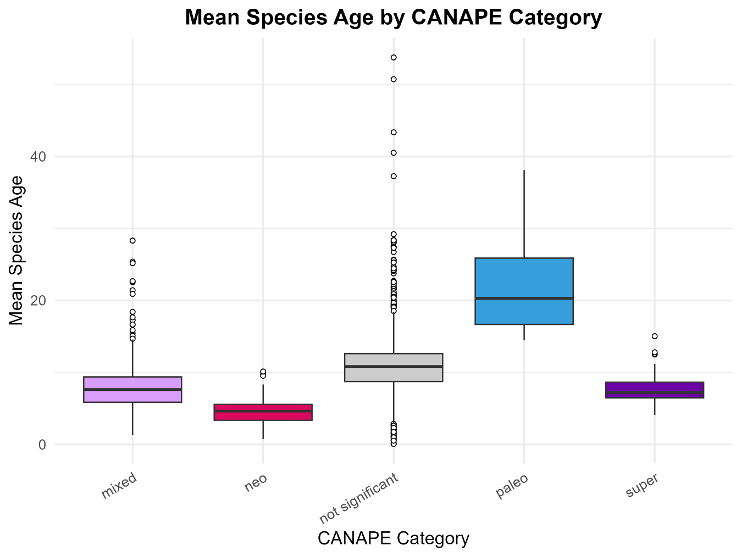

# S04: CANAPE results at 50 km resolution

This report follows the methodologies developed by **Mishler et al. (2020, 2021)** and **Thornhill et al. (2016)**, including:

* **Phylogenetic Diversity (PD)** – Total branch length of a phylogeny in a given area.
* **Relative Phylogenetic Diversity (RPD)** – Compares observed PD to expected PD under a null model.
* **Phylogenetic Endemism (PE)** – Measures how evolutionary history is spatially restricted.
* **CANAPE (Categorical Analysis of Neo- and Paleo-Endemism)** – Identifies areas with significant neo-endemism (recent diversification) or paleo-endemism (ancient relict lineages).

We rely on the canaper package to obtain the metrics. Below are the visualizations produced by the analysis.

This reports the results obtained using an hexagonal grid with a width of 100 km, which resulted in 2137 cells. The analysis incorporates:

* A phylogenetic tree (final_tree.nex)
* Community composition data (com_matrix_[resolution].csv)
* Environmental variables from CHELSA paleoclimatic layers
* Geodiversity metrics
* Age by cell according to the phylogenetic data

## Observed metrics

### Species Richness and Redundancy

### Phylogenetic Diversity (PD) and Endemism (PE)

**Relative Phylogenetic Diversity (RPD) and Endemism (RPE)**

Is a ratio that compares the values observed with those obtained from a comparison tree, wich retains the topology but makes all branches of equal length. Both of these indices are ratios that compare the PD and PE observed on the actual tree in the numerator to that observed on a comparison tree in the denominator. Thus, if the ratio is large, there must be many long branches present, while if it is small there must be many short branches present.

### Statistical significance of metrics

The statistical significance of PD, PE, RPD and RPE were assessed using a randomization with a null model. For all variables, a two-tailed test was applied as both indices can have values significantly higher or significantly lower than the null. If the observed value fell into the highest 2.5% of the distribution for that grid cell it was judged significantly high; if the observed value fell into the lowest 2.5% of the distribution for that grid cell it was judged significantly low.

## CANAPE Results (Neo-/Paleo-Endemism)

This classifies significant endemism hotspots in a “categorical analysis of neo- and paleo-endemism” (CANAPE, [Mishler et al. 2014](https://doi.org/10.1038/ncomms5473)). Uses significance values for PE, RPE, and CE to categorize sites into five endemism cateogories:

First, if a cell has PE or CE are significantly high then:

* **Neoendemism:** RPE significantly low at alpha / 2 (two-tailed test).
* **Paleoendemism:** RPE significantly high at alpha / 2 (two-tailed test).
* **Mixed-endemism:** RPE not significant.
* **Super-endemism:** RPE not significant, but PE or CE are significantly high (p<0.01)

